2B) To demonstrate use of general purpose port i.e. Input/ output port of two controllers for data

transfer between them.

SOLN:

Algorithm:

First Microcontroller . Set Port 2 as output port. 2. Set a Hex data value at port2.

Second Microcontroller . Set P1 as input port and port 2 as output port. 2. Redirect input from port 1

to port 2.

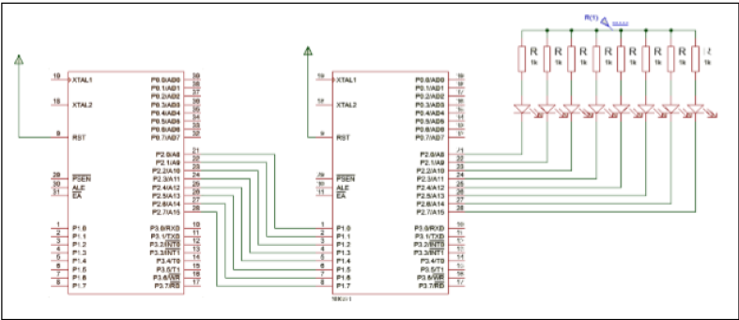

Code

Controller 1:

#include<reg51.h>

void main()

{

unsigned int i;

while (1)

P2 = 0X55; //Set up a hex value at port 2 of first controller

for (i=0;i<1000;i++);

}

Controller 2 :

#include<reg51.h>

void delay(unsigned int t);

void main()

{

while(1)

{

P1 = P2;

delay(1000);

}

}

void delay(unsigned int t)

{

unsigned int i,j;

for(i=0;i<=t;i++)

for(j=0;j<=1275;j++);

}

Expt 3a

3. A Port I / O: Use one of the four ports of 8051 for O/P interfaced to eight LED’s. Simulate binary

counter (8 bit) on LED’s

SOLN:

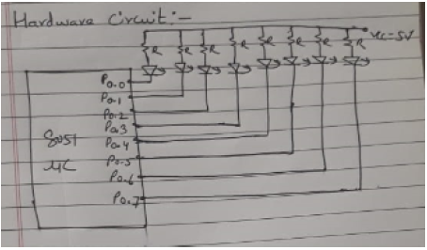

#include<reg51.h>

void delay(unsigned int t);

void main(void)

{

while(1)

{

P0++; // Increment Port 1 (Binary Counter)

delay(100);

}

}

void delay(unsigned int t)

{

unsigned int i,j;

for(i=0;i<=t;i++)

for(j=0;j<=1275;j++);

}

Expt3b

B To interface 8 LEDs at Input-output port and create different patterns

SOLN:

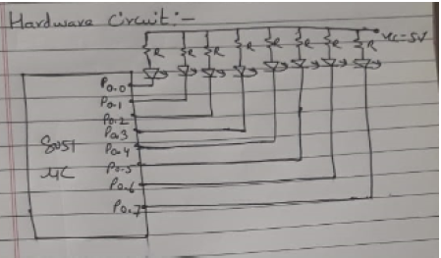

#include<reg51.h>

void delay(unsigned int t);

void main(void)

{

while(1)

{

P1=0xAA;

delay(100);

P1=0x55;

delay(100);

}

}

void delay(unsigned int t)

{

unsigned int i,j;

for(i=0;i<=t;i++)

for(j=0;j<=1275;j++);

}

NOTE:

